**Ideation Phase**

**Brainstorm & Idea Prioritization**

|  |  |
| --- | --- |
| Date: | 18 June 2025 |
| Team ID: | LTVIP2025TMID36354 |
| Project Name: | Enchanted Wings: Marvels of Butterfly Species |
| Maximum Marks: | 4 Marks |

# 🌟 Ideation Phase

Brainstorming encourages creative and open problem-solving by allowing team members to explore a wide range of ideas.  
This session supports selecting and refining ideas that best fit the chosen problem statement related to butterfly species classification.

### ✅ Step-1: Team Gathering, Collaboration and Selecting the Problem Statement

The team gathered to address challenges in butterfly identification in the field.  
After empathy mapping and customer journey analysis, the selected problem statement is:

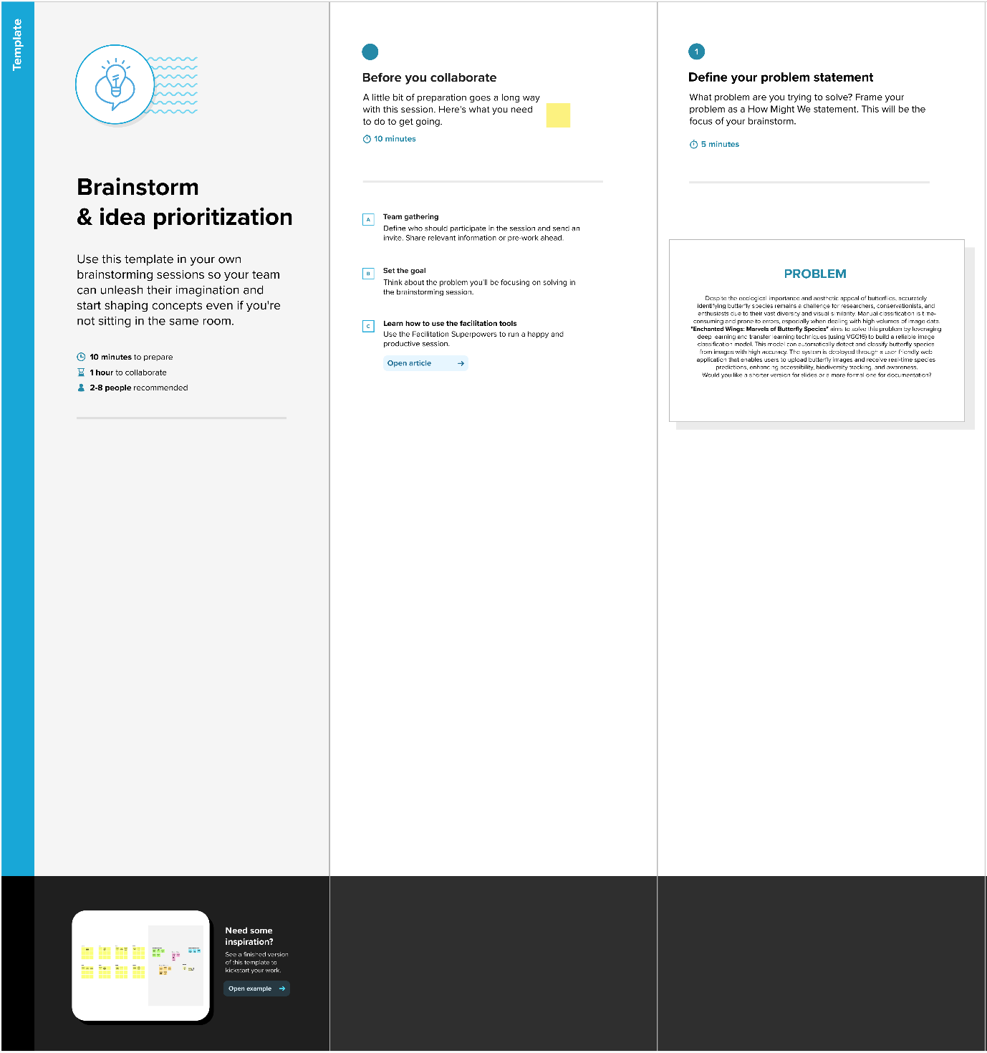**How can we help users (students, researchers) identify butterfly species easily and accurately using AI-powered image classification?**

## 💡 Step-2: Brainstorming, Idea Listing and Grouping

Below is a list of ideas generated during the brainstorming session:

* Use transfer learning with VGG16 to classify butterfly images
* Build a simple Flask-based web application
* Enable drag-and-drop image uploads
* Display predicted species with image preview
* Add links to species details (e.g., habitat, conservation)
* Include a feedback option to improve future predictions
* Optimize image preprocessing for fast model loading
* Deploy app to a cloud platform for access on any device

## 🎯 Step-3: Idea Prioritization

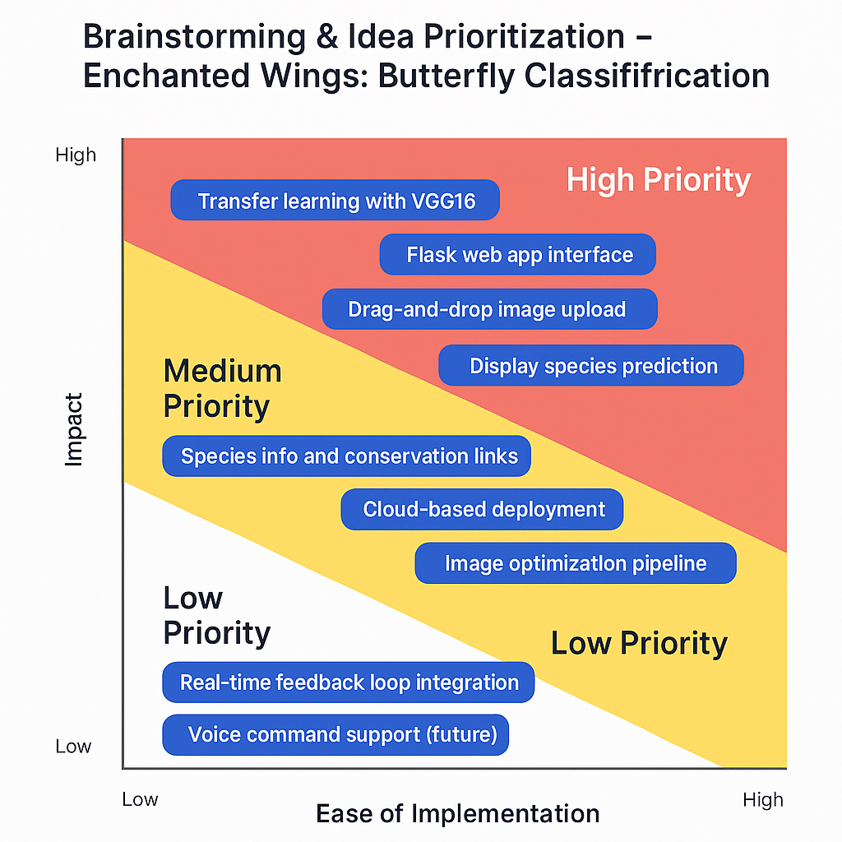

Ideas were evaluated based on feasibility, impact, and ease of implementation:

**🔴 High Priority**

* Transfer learning with VGG16
* Flask web app interface
* Drag-and-drop image upload
* Display species prediction

**🟡 Medium Priority**

* Species info and conservation links
* Cloud-based deployment
* Image optimization pipeline

**⚪ Low Priority**

* Real-time feedback loop integration
* Voice command support (future)